**ECE 381**

**Karthik Calanji Sridhar**

**UIN:01054555**

**Dr. Li**

**Project 2 & 3**

**Project 2**

Question 1

Part A

System Function is:

$$H\left(z\right)= \frac{1}{z^{2}-0.75z+0.1}$$

PART B

FIGURE:

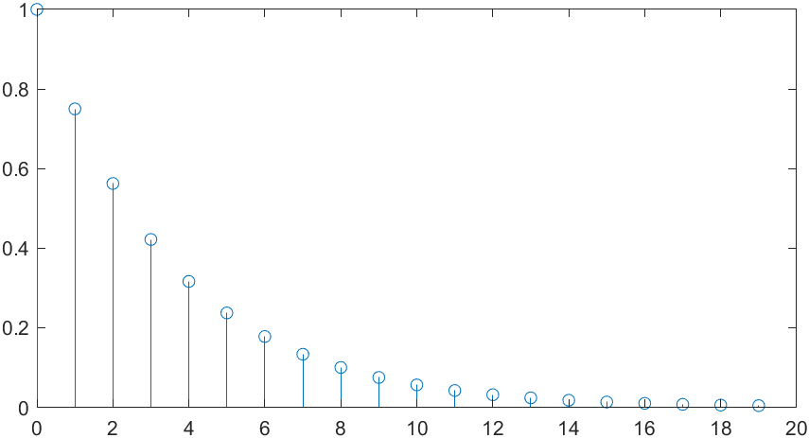

CODE:

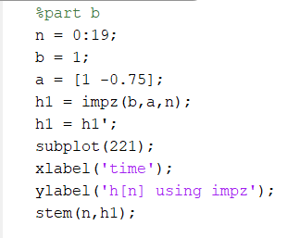

PART C

FIGURE

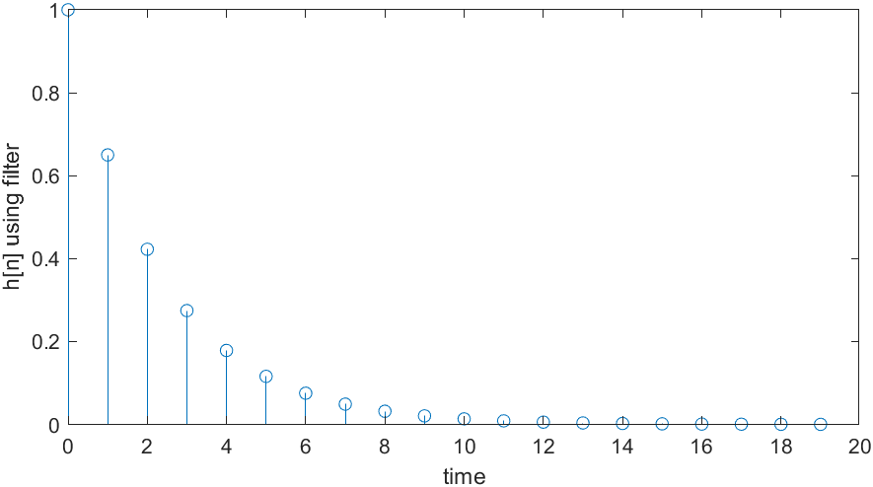

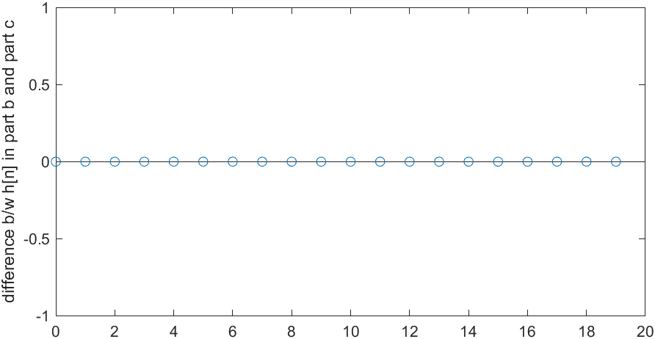

CODE:

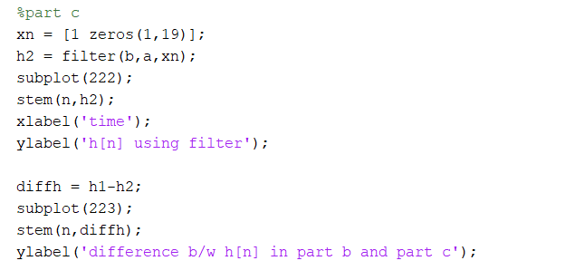

PART D

FIGURE

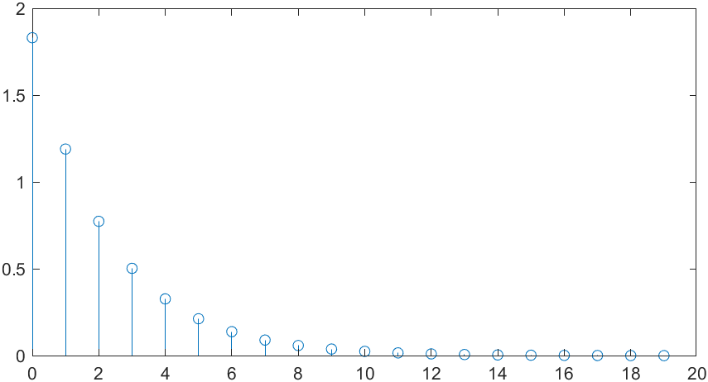

CODE:

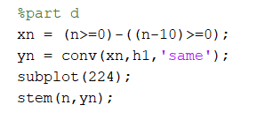

PART E

FIGURE:

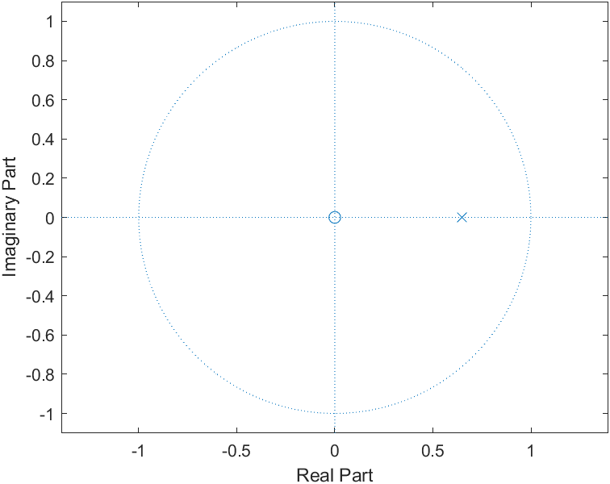

CODE:

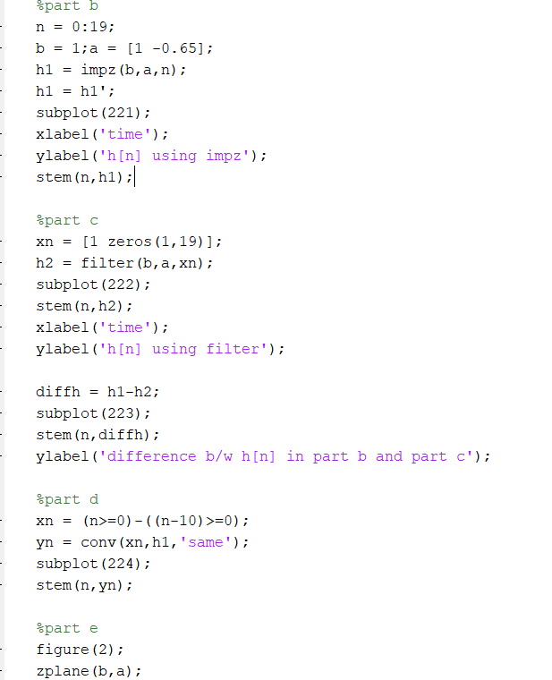

**PROJECT 3**

QUESTION 1:

Figures:

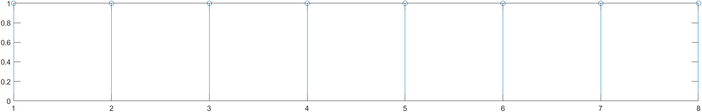

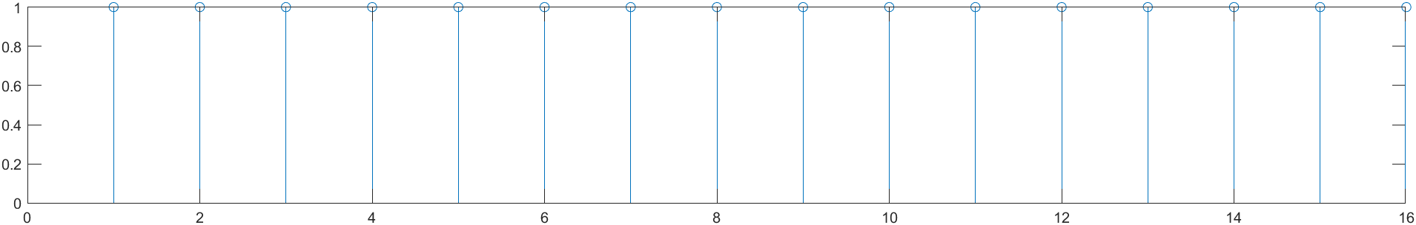

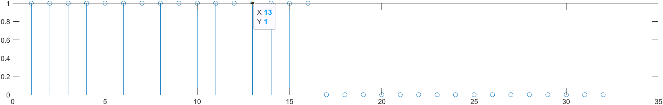

CODE:

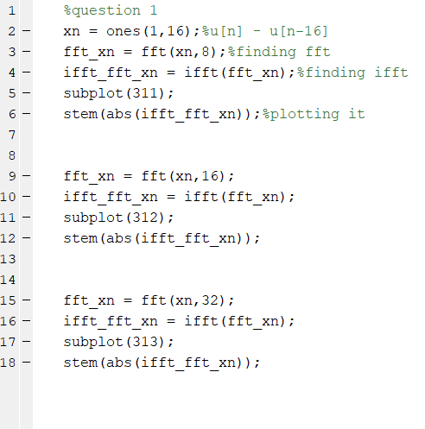

QUESTION 2

FIGURE:

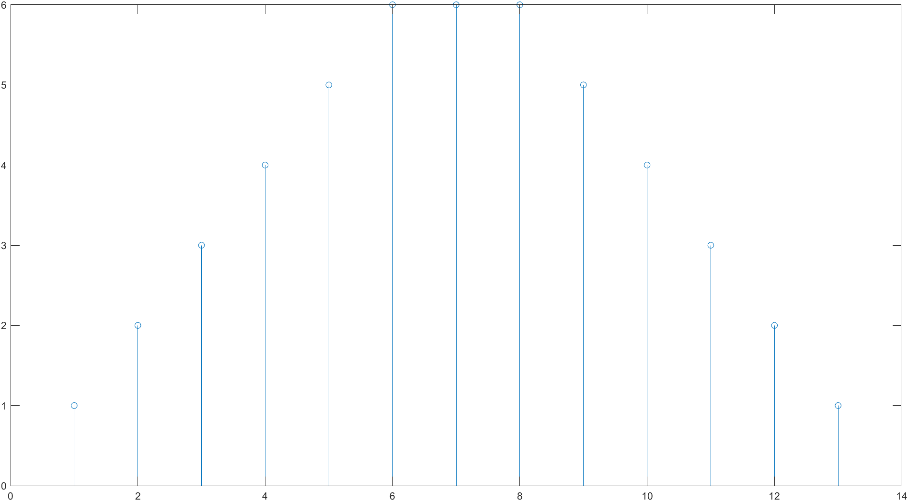

CODE:

